## **Experiment Name:** Process handling in Linux.

**Objective:**

**“ls” command :**   
  
 Used to list folder contents.  You can view many kinds of file and folder attributes.

1. **ls** By itself, ls will simply list all your files in the current folder.  From fact #4, this literally does **ls .**
2. **ls -l** Provides a longer listing format including owners, permissions, size, and date modified.
3. **ls -a** Displays hidden files and folders as well as the normal listing.
4. **ls -al** Combine options to display both hidden files and in the long format.
5. **ls -h** Show file sizes in human readable format (K, M, Gbyte) filesizes instead of bytes.  Often used in conjuction with the **-l** flag.
6. You can view files in directories you are not even in.  If I am in /home/justin/Desktop, and I want to view a file in /home/justin, I can do **ls ../** list files one directory back (and not have to go back to do so.)

**Screenshot:**

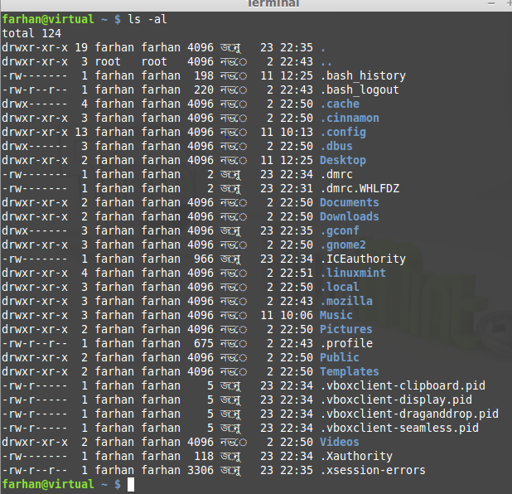

**“Ps” command:**

**List processes:**

1. **ps aux** List all processes in detail running on the system, including user, Process ID (PID), and name of process.  Using this, one can view their process list and if necessary, kill unnecessary or stalled processes.

**Screenshot:** 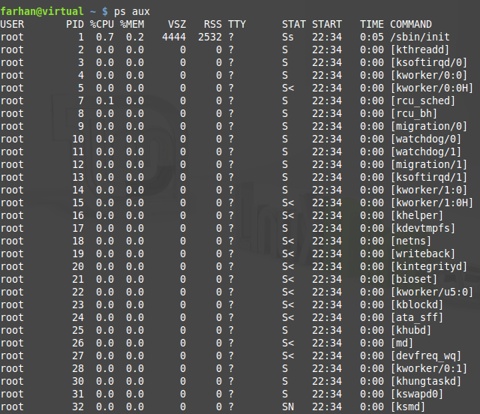

**Find out the PID (process id):**

Use the ps or pidof command to find out PID for any program  
OR ,

ps aux | grep lighttpd

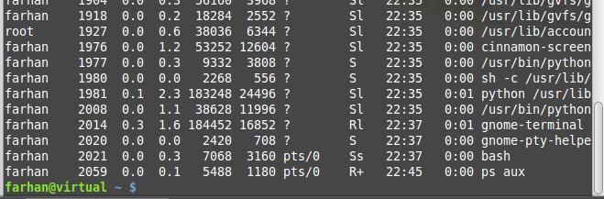

**kill / killall / xkill command:**

Kill offending processes.

1. **Kill PID** PID is a number referencing the offending process.  One should obtain the PID from a command like **ps aux**.  If a process refuses to die, one can alternatively specify **kill -9 PID** which should terminate the process by any means, even uncleanly or if it will mess up the system.
2. Kill the process using process name.
3. kill the process using a PID
4. A note about sending stronger signal # 9 (SIGKILL)
5. If no signal specified in the kill command, signal # 15 (SIGTERM), is sent by default.
6. Sometime signal #15 is not sufficient. For example, vlc may not be killed by signal #15 due to open sockets. In that case process (PID) would be killed with the powerful signal # 9:

**Screenshot:**



**7. killall program**  Killall kills *by name* all instances of said program.  If there are for example 3 firefox sessions open, **killall firefox** will do just that; kill all firefox sessions.  **kill** would simply take the specified PID of the offending firefox process you wish to kill, and kill that one only.

**Screenshot:**



1. **xkill** is a GUI way to click and kill windows.  Typing in **xkill** should present a skull-and-crossbones icon, and the next window clicked on will be killed.

**Screenshot:**



**Short cut :**

1. When we lost in a directory, the short cut is “pwd”

**Screenshot:**



1. When we want to calculate our disk space quickly,  **df -h** can give us a quick checkup.

**Screenshot:**

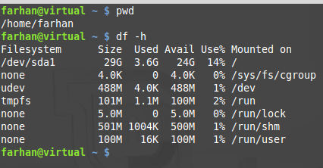

1. When we want to calculate the size of a folder or file quickly,  **du -cksh target_name** can do exactly that**.**

**Screenshot:**

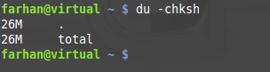

**Discussion**: After doing this lab we came to know that how to see the active process that’s going on the linux. By using the command we can shortly see the process, and we can kill the process. So , this lab is too much important to us.